Data Management System

In this assignment we need to develop a menu based online application for Morris Health Services which consists of following modules

1. Employee & Facility Management: using this module Morris can manage details of Medical facilities, Employees and Insurance company’s details. Morris can able to view all existing records of medical facilities, employee and insurances. Employees can be add in various categories such as Physician, Nurses, Administrative Staff and Others.
2. Patient Management: using this module new patients details will be added to database and can create appointments for each patients and can generate invoice upon final treatment and can see daily revenue reports based on invoice
3. Reporting: can be to generate various reports based on average revenue of each insurance companies, List of appointments for selected physician on selected date and total revenue on each date etc.

To implement this project we have designed following MYSQL database

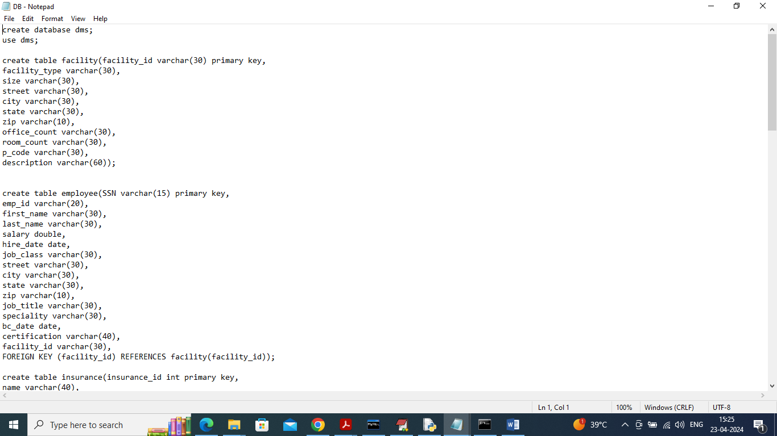

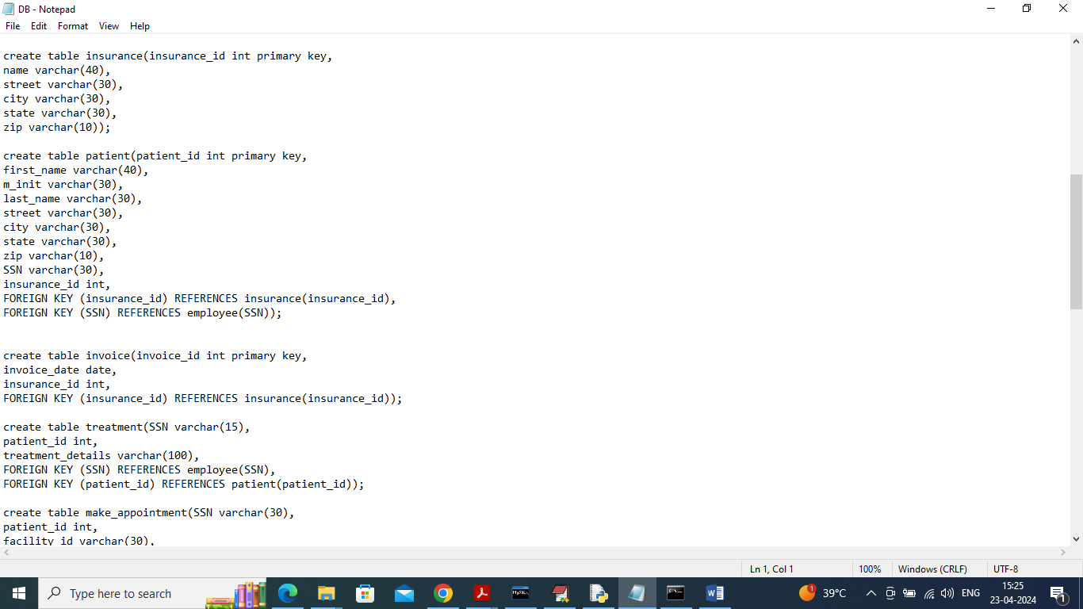

In above two screens can see Relational table structure for Morris application database.

To run project install python 3.7.2 and then install all packages given in requirement.txt file and then install MYSQL database and then copy content from DB.txt file and paste in MYSQL console to create database.

Now double click on ‘run.bat’ file to start python server and get below page

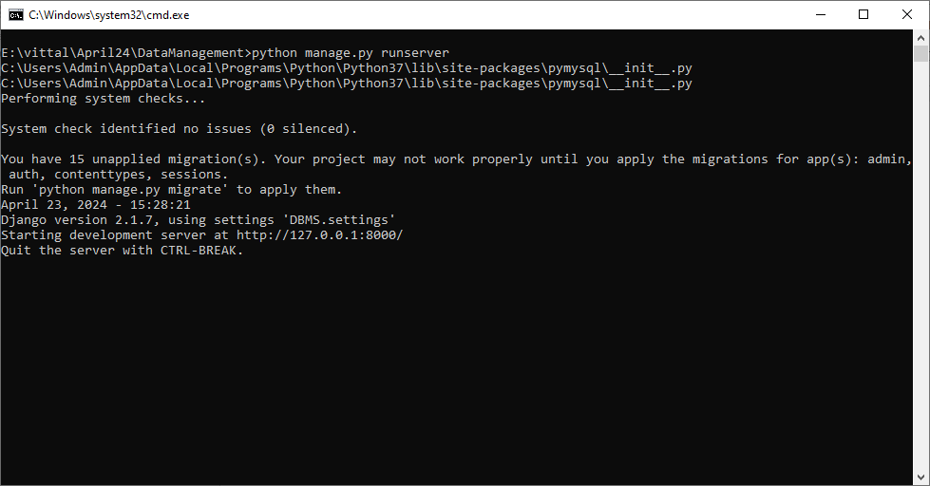

In above screen python server started and now open browser and enter URL as <http://127.0.0.1:8000/index.html> and press enter key to get below page

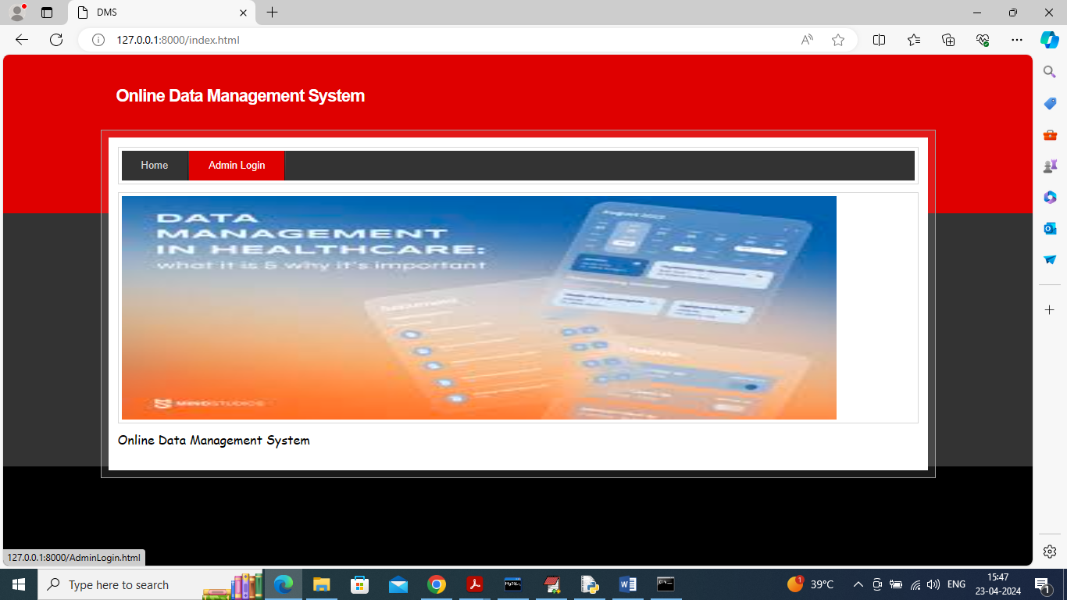

In above screen click on ‘Admin Login’ link to get below page

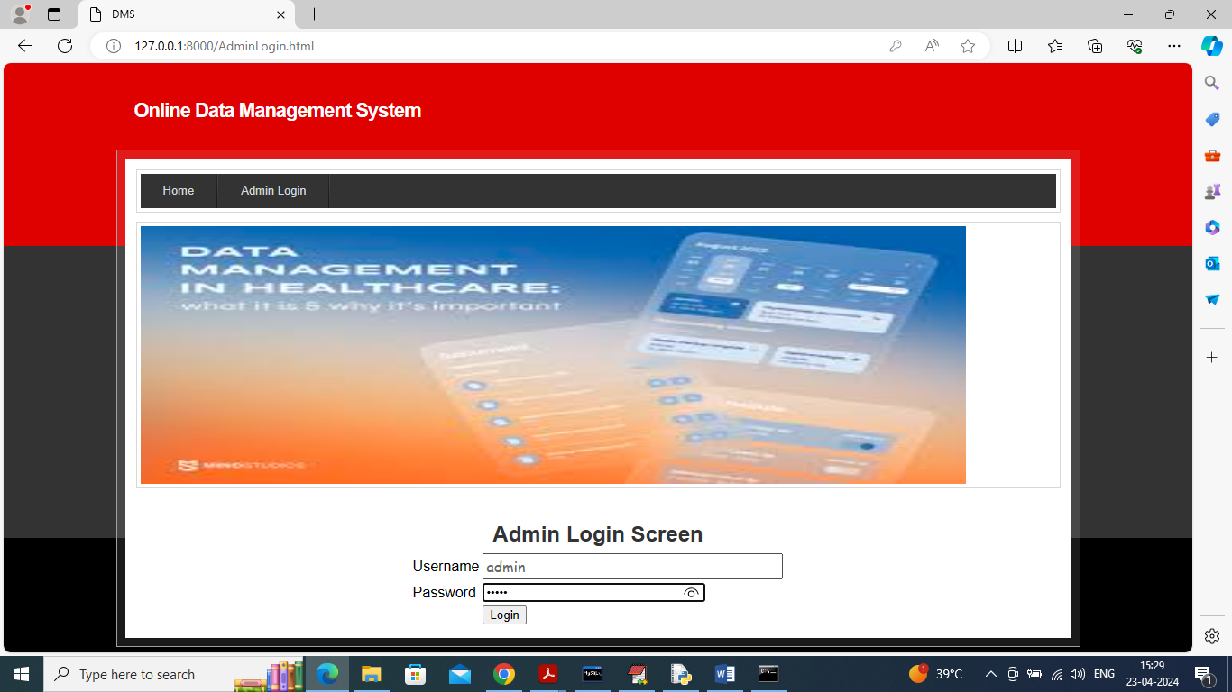

In above screen admin login to application using username and password as ‘admin and admin’ and after login will get below page

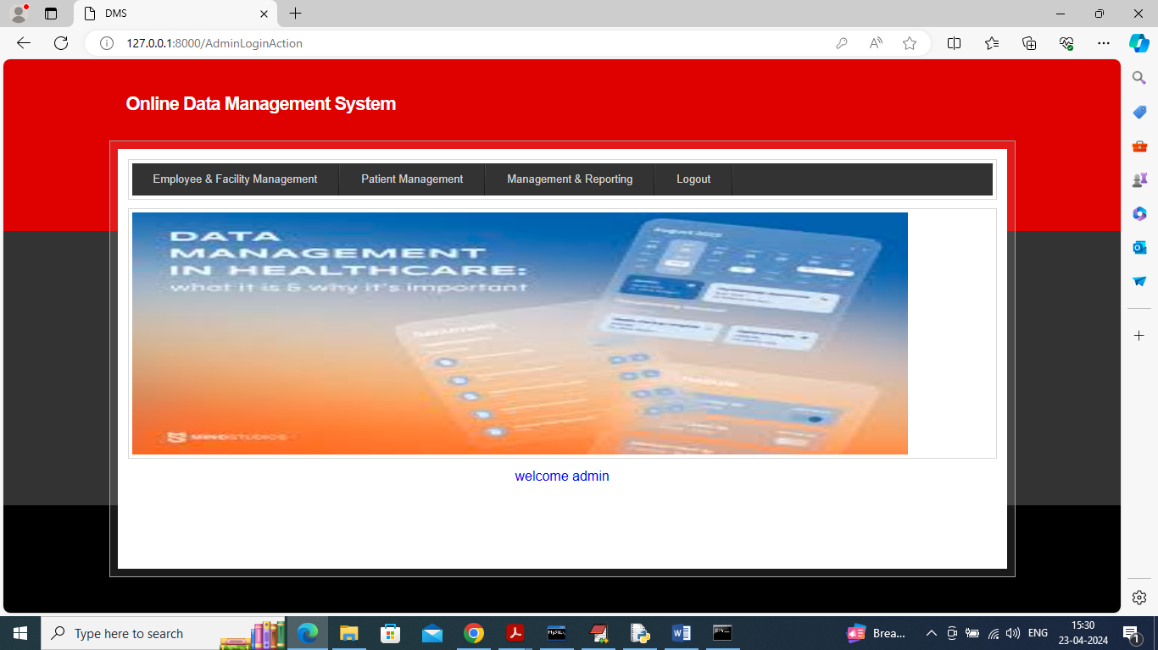

In above screen admin can click on ‘Employee & Facility Management’ link to add employee details and get below page

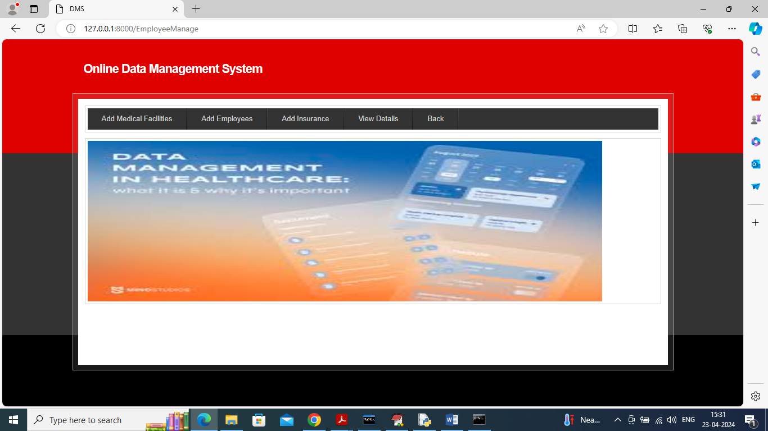

In above screen admin can click on ‘Add Medical facilities’ link to get below page

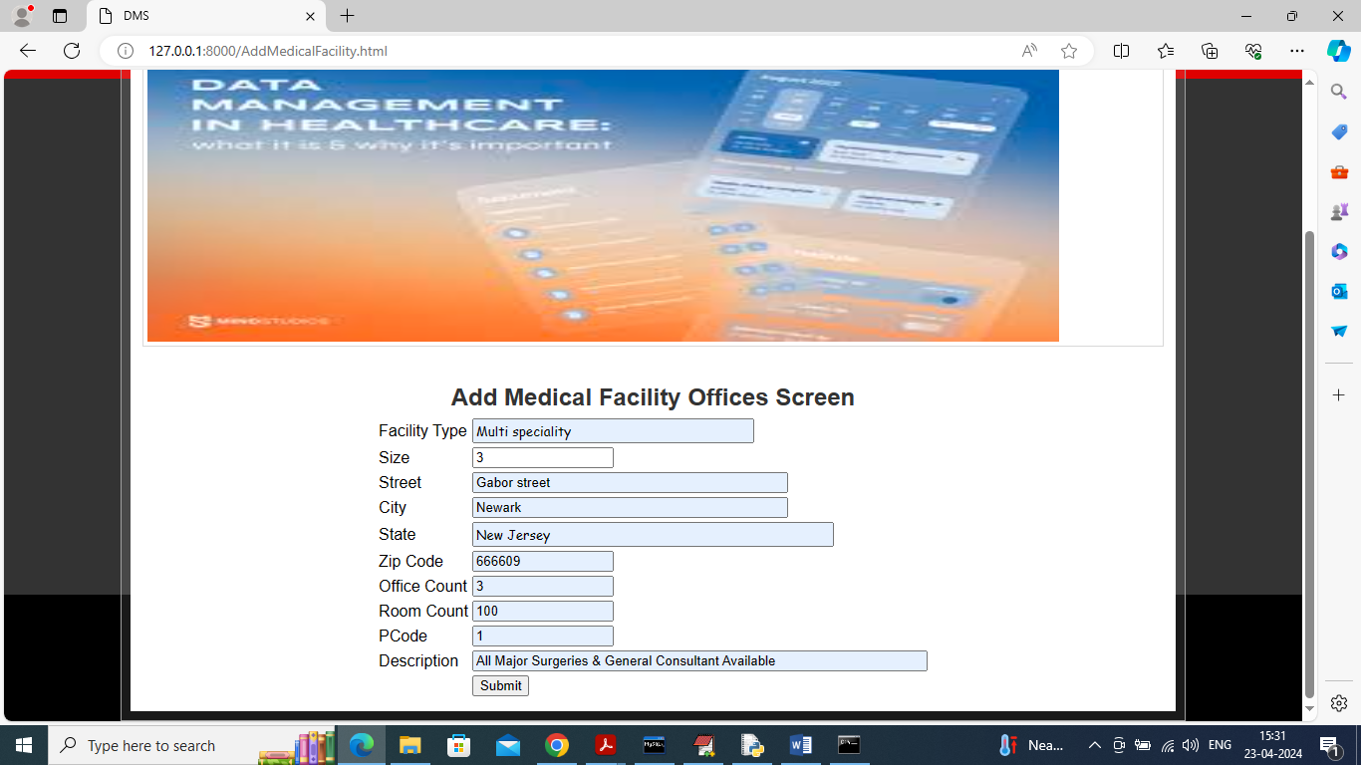

In above screen medical facility details are adding and then press button to get below page

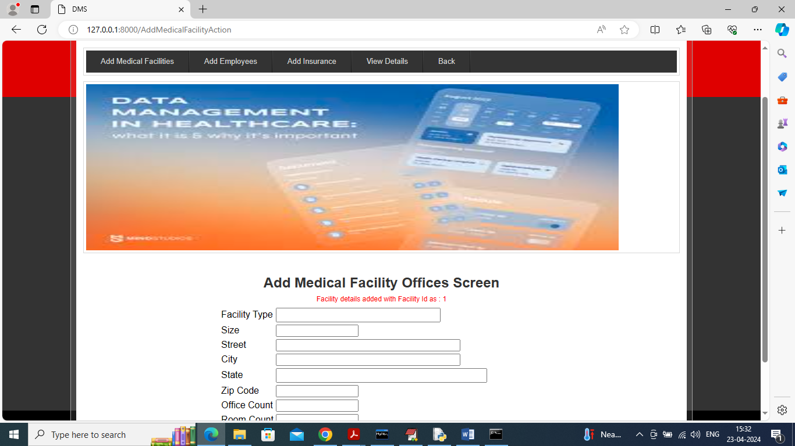

In above screen in red color text can see facility details added and can see generated Id and now click on ‘Add Employees’ link to add employee details

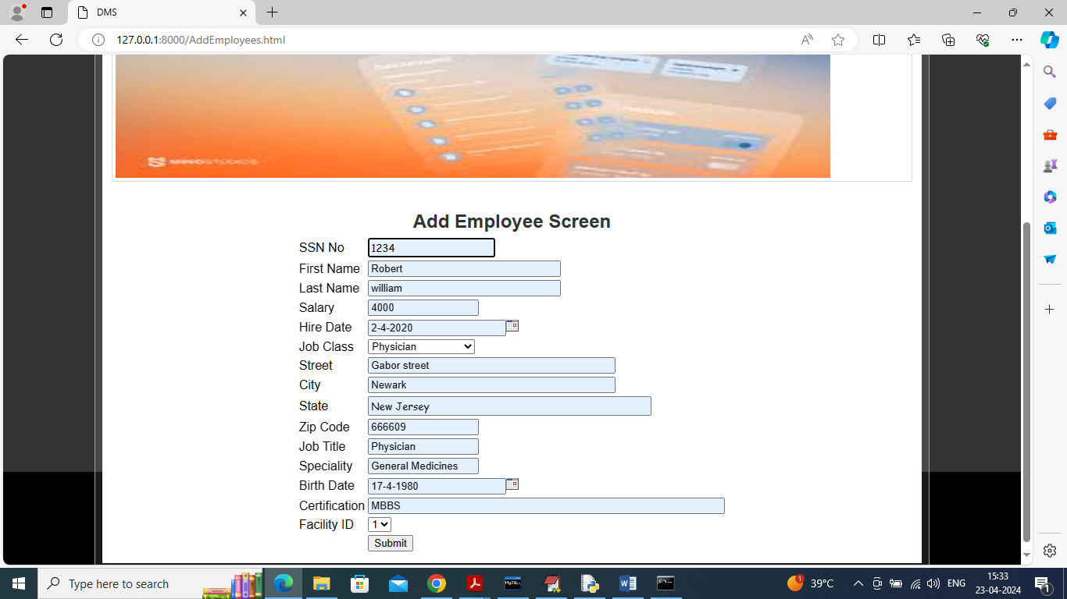

In above screen adding employee details and then press button to get below page

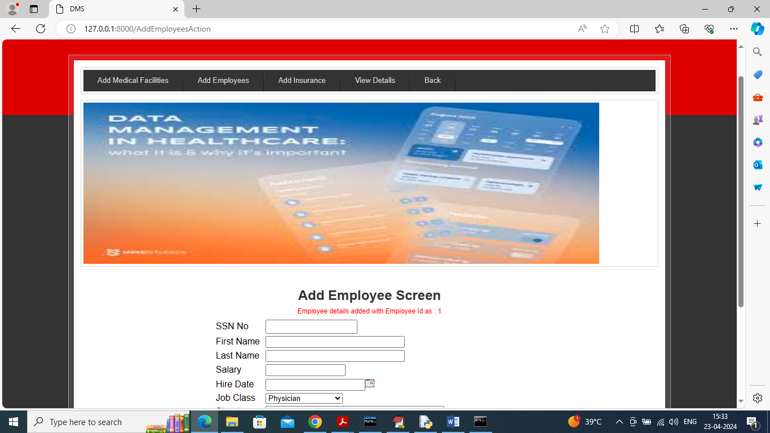

In above screen employee details added and now click on ‘Add Insurance’ link to get below page

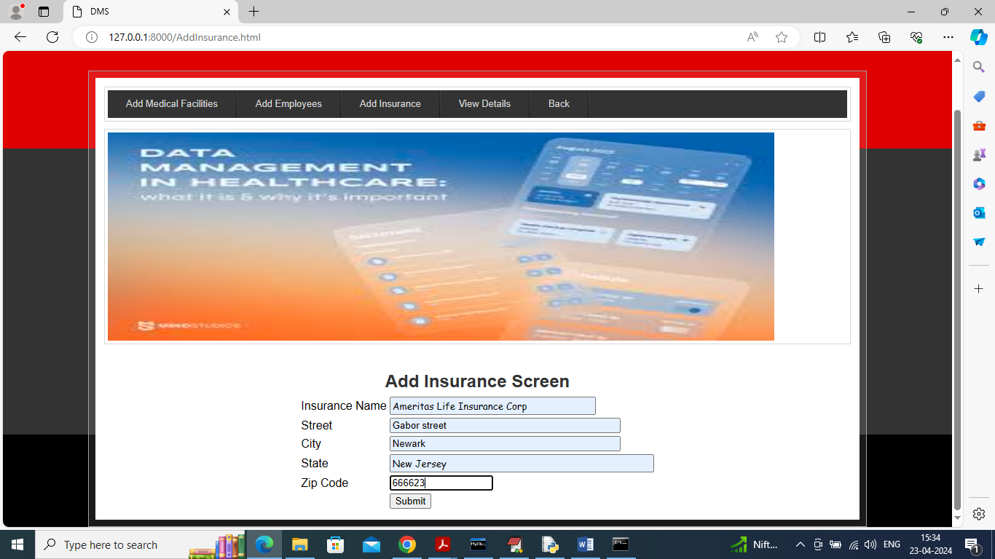

In above screen adding insurance company details and then press button to get below page

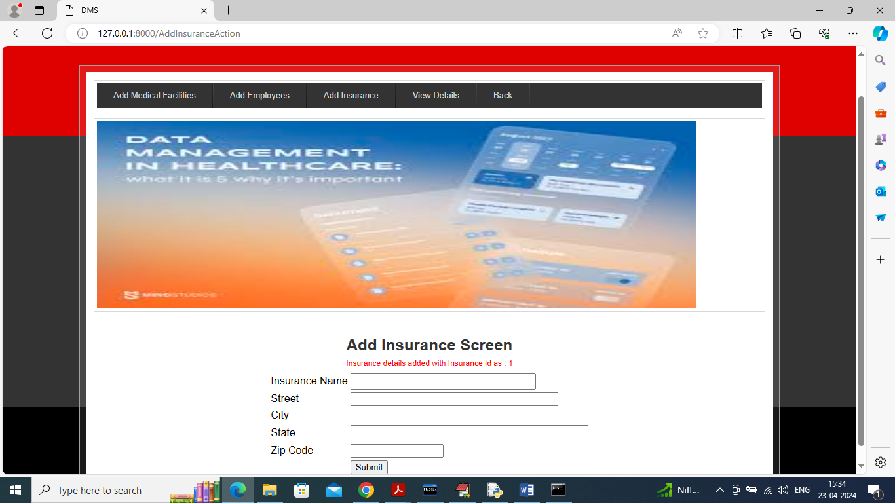

In above screen insurance details added and now click on ‘View Details’ link to view all details

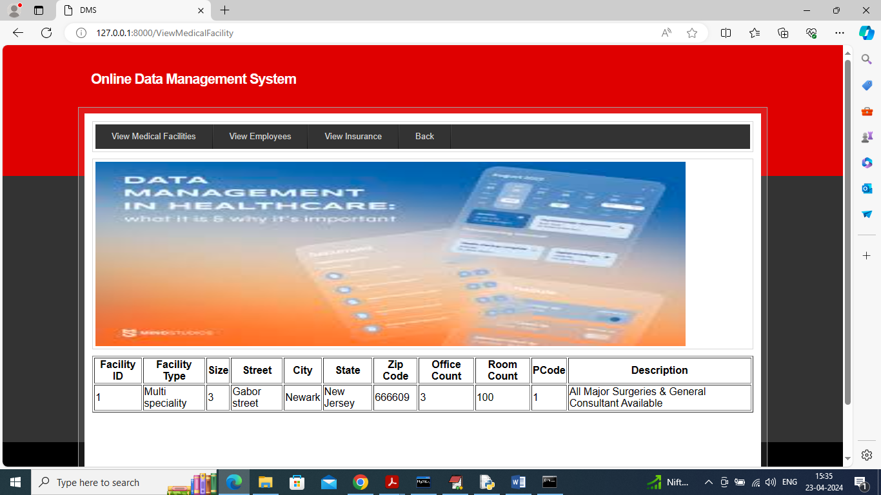

In above screen click on ‘View Medical facility’ link to view add medical facility details and now click on ‘View Employee’ link to get below page

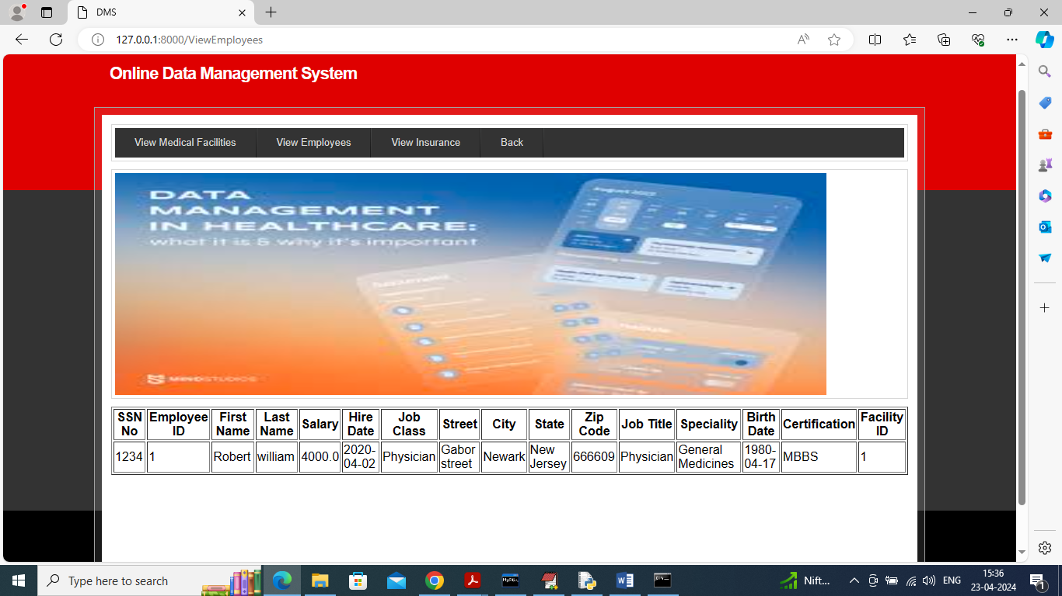

In above screen can see employee details and now click on ‘View Insurance’ link to get below page

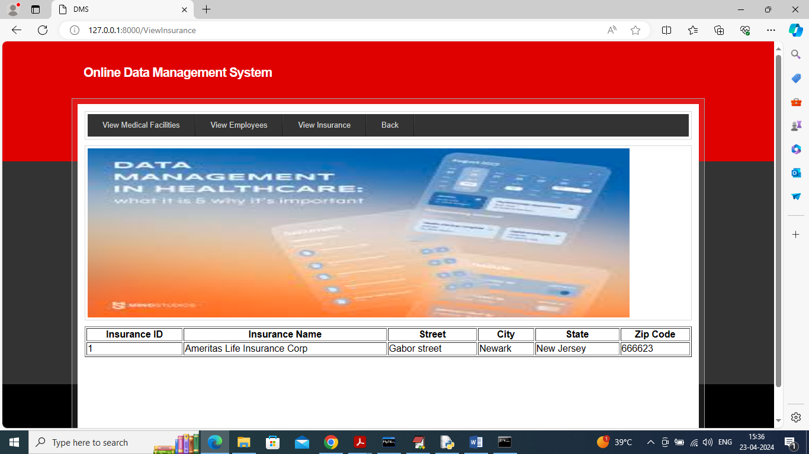

In above screen can see insurance company details and now click on ‘Back’ link to get back to Main Menu

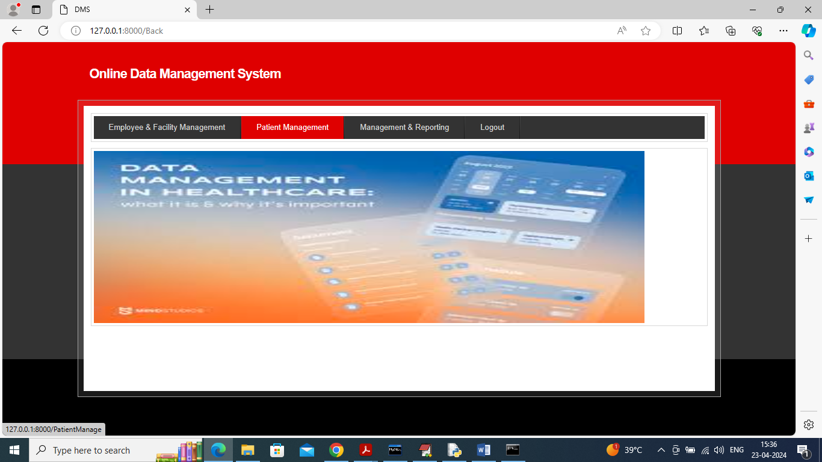

In above screen click on ‘Patient Management’ link to get below page

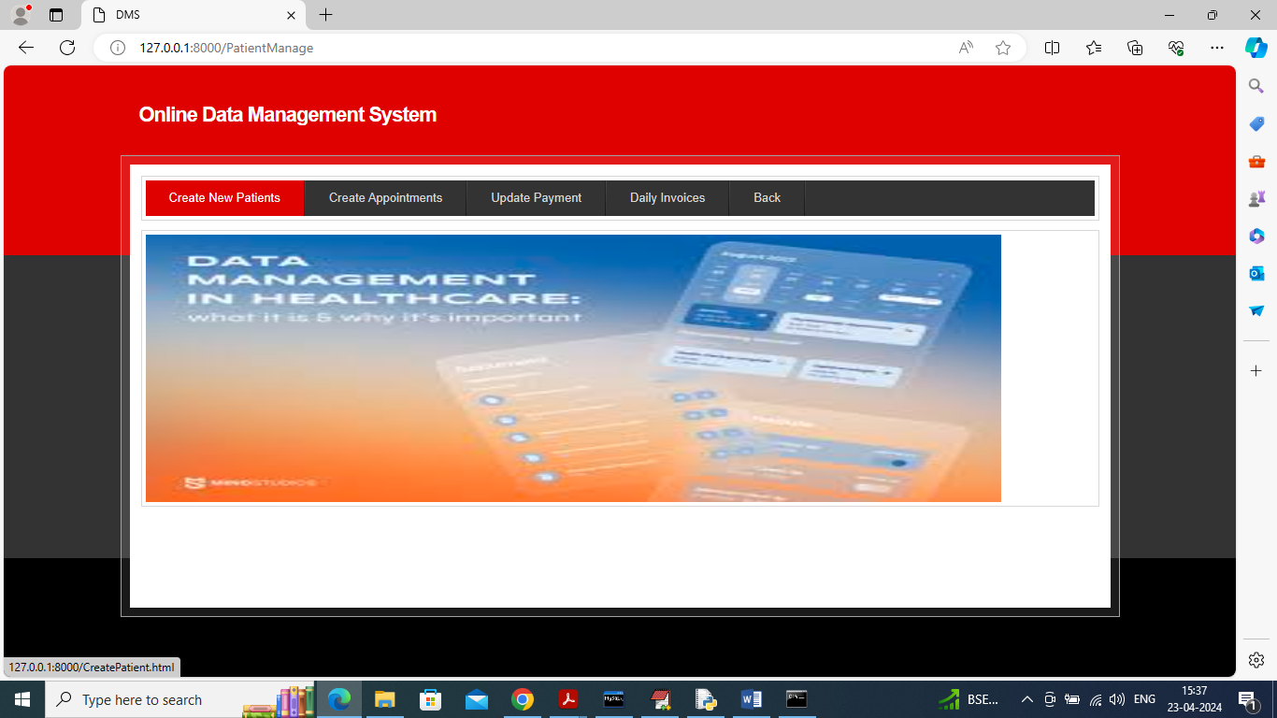

In above screen click on ‘Create New Patient’ link to get below page

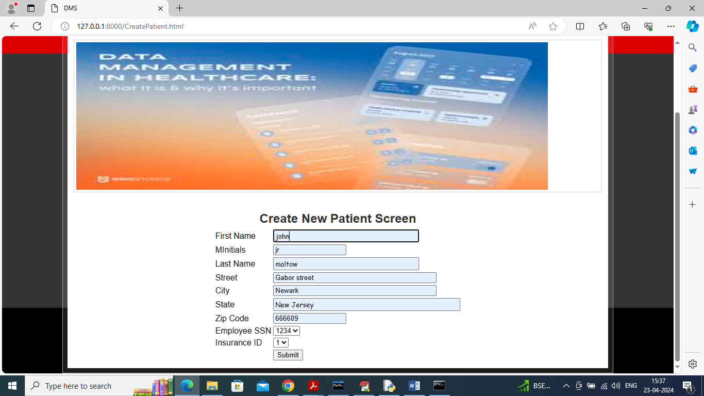

In above screen creating patient record and then press button to get below page

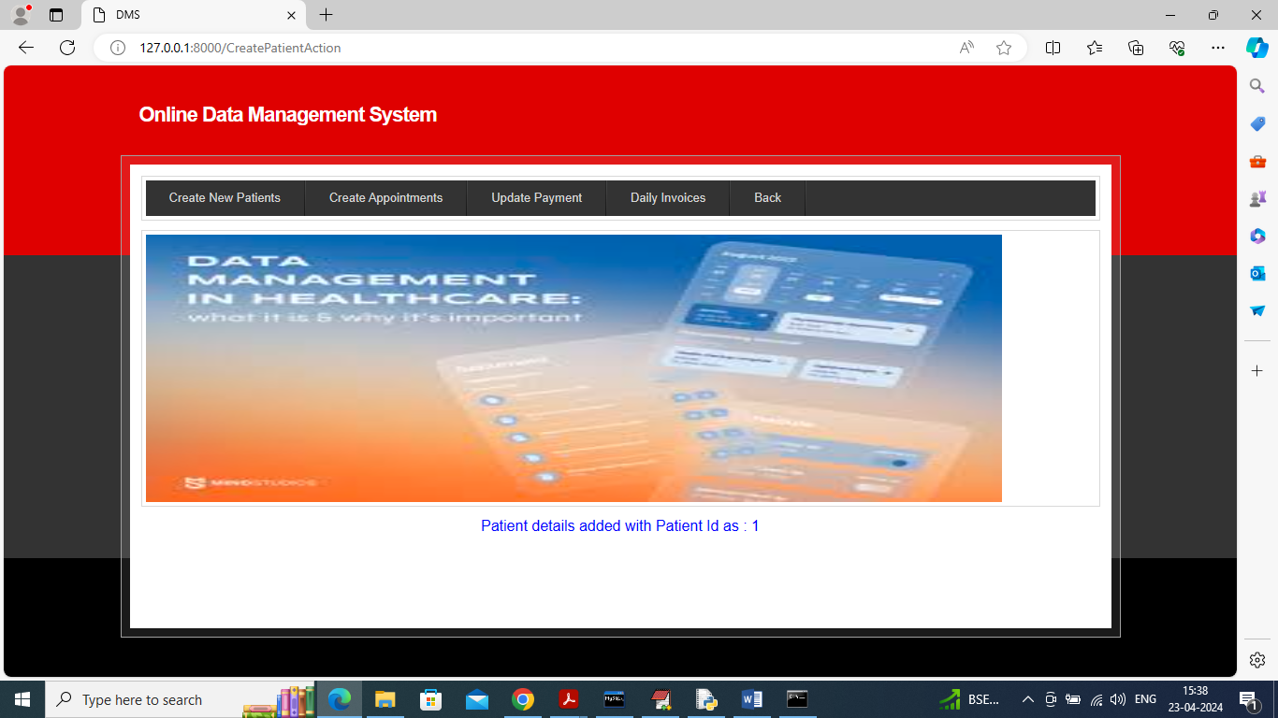

In above screen patient record created and now click on ‘Create Appointment’ link to get below page

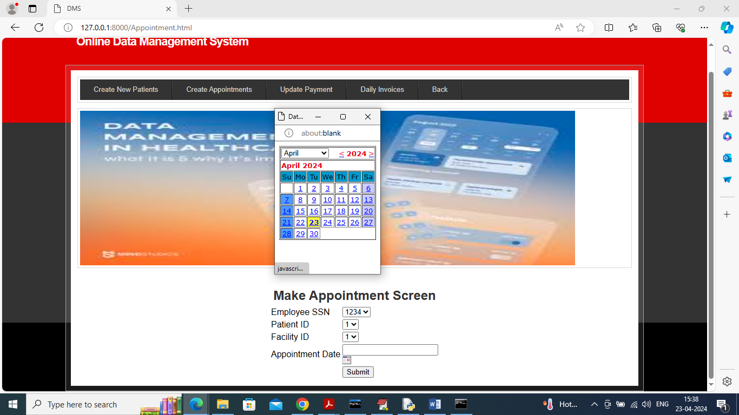

In above screen select physician SSN and then choose appointment date and press button to create appointment and get below page

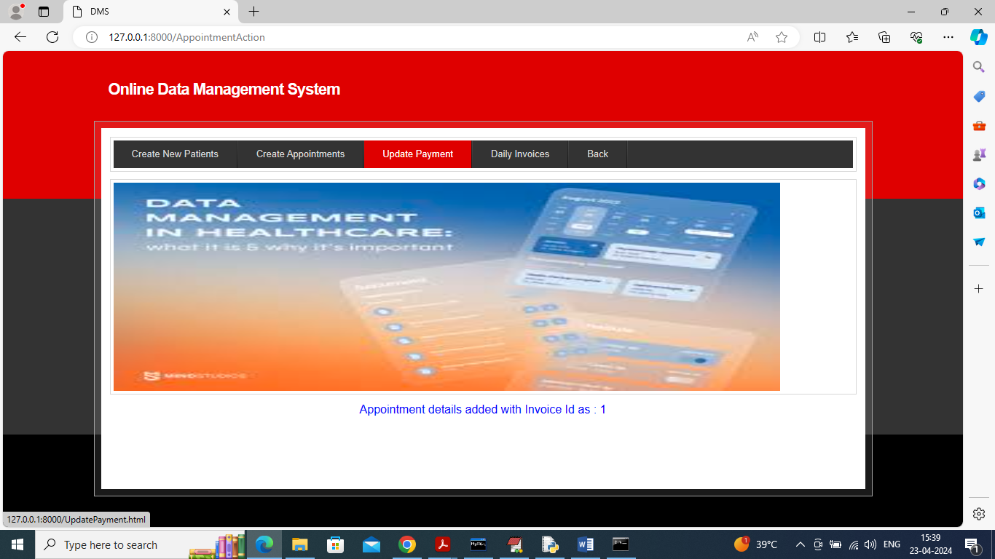

In above screen appointment created and once all consultation over then employee can click on ‘Update Payment’ link to generate final invoice and get below page

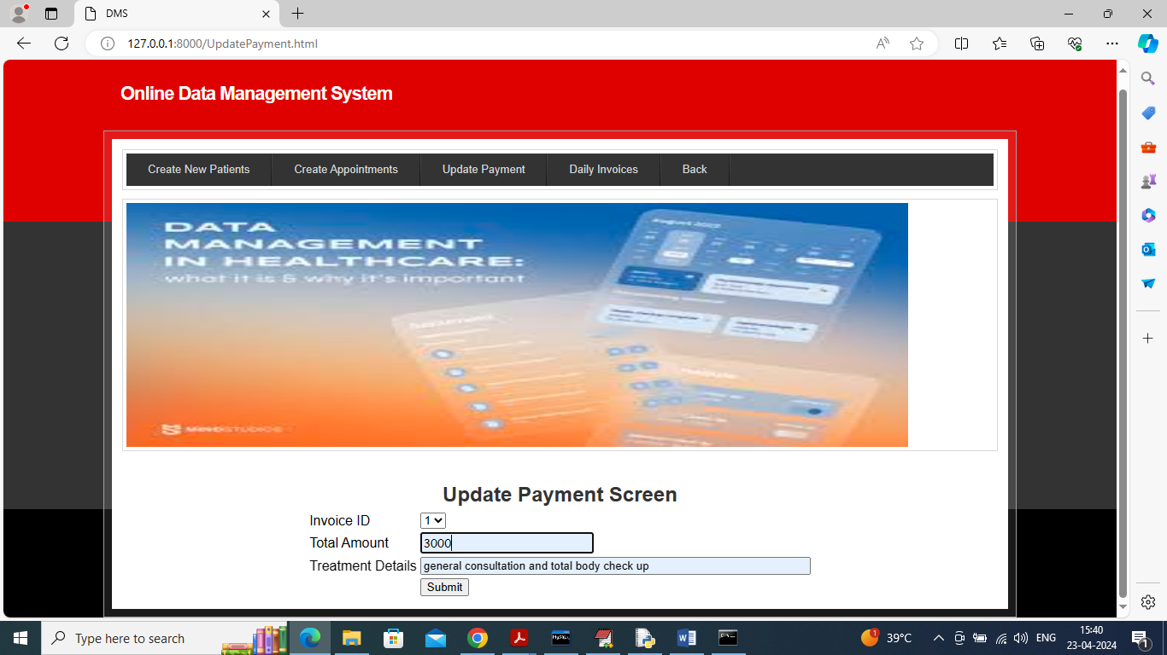

In above screen select invoice id and then enter amount and treatment details and then press button to get below page

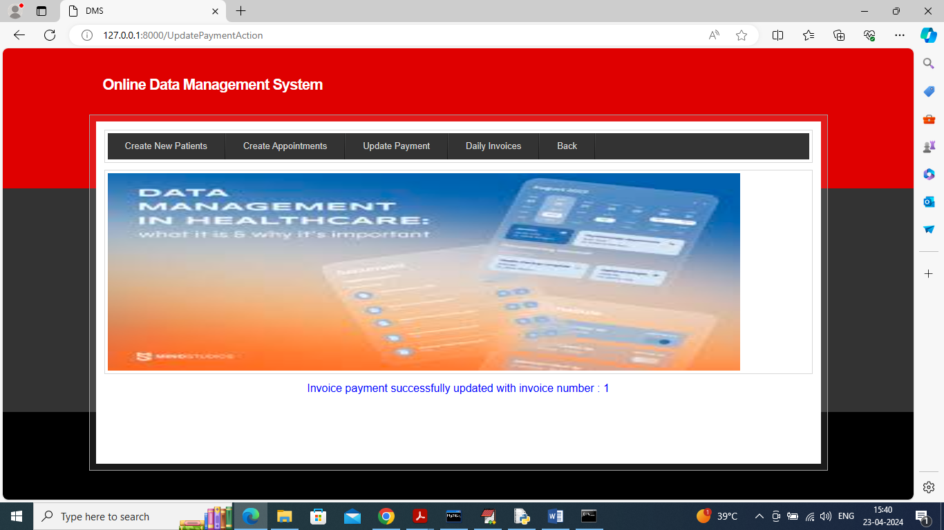

In above screen payment invoice created successfully and now click on ‘Daily Invoices’ link to view todays generated invoices

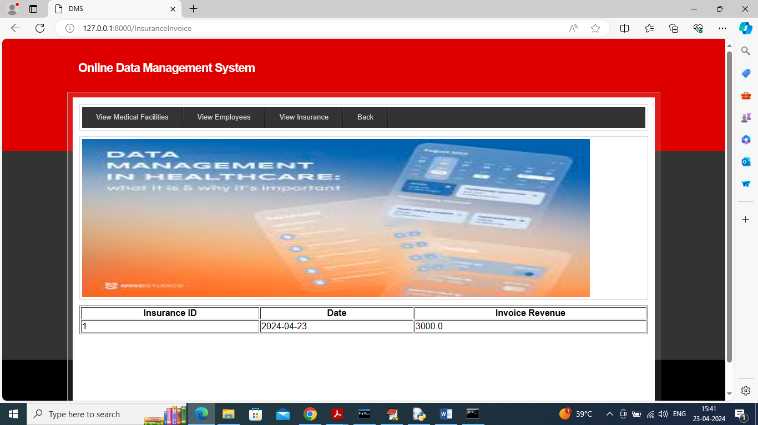

In above screen can see list of today’s invoices and now click on ‘Back’ link to get back to Main Menu

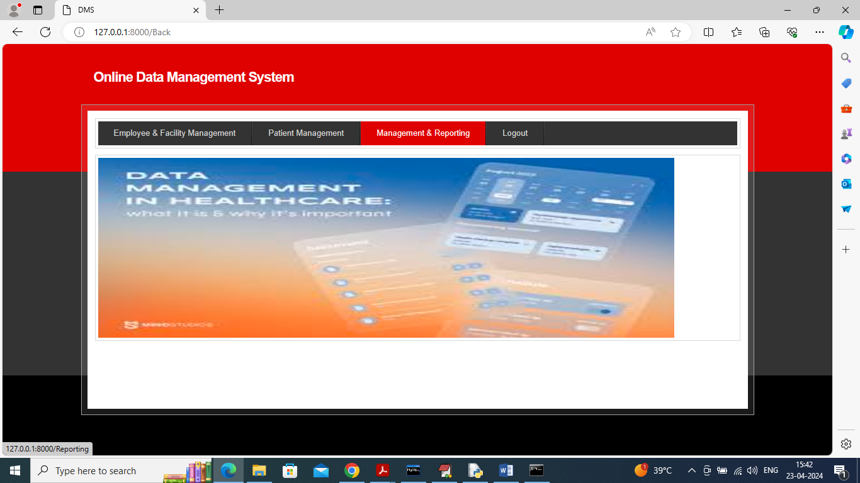

In above screen click on ‘Management & Reporting’ link to get below page

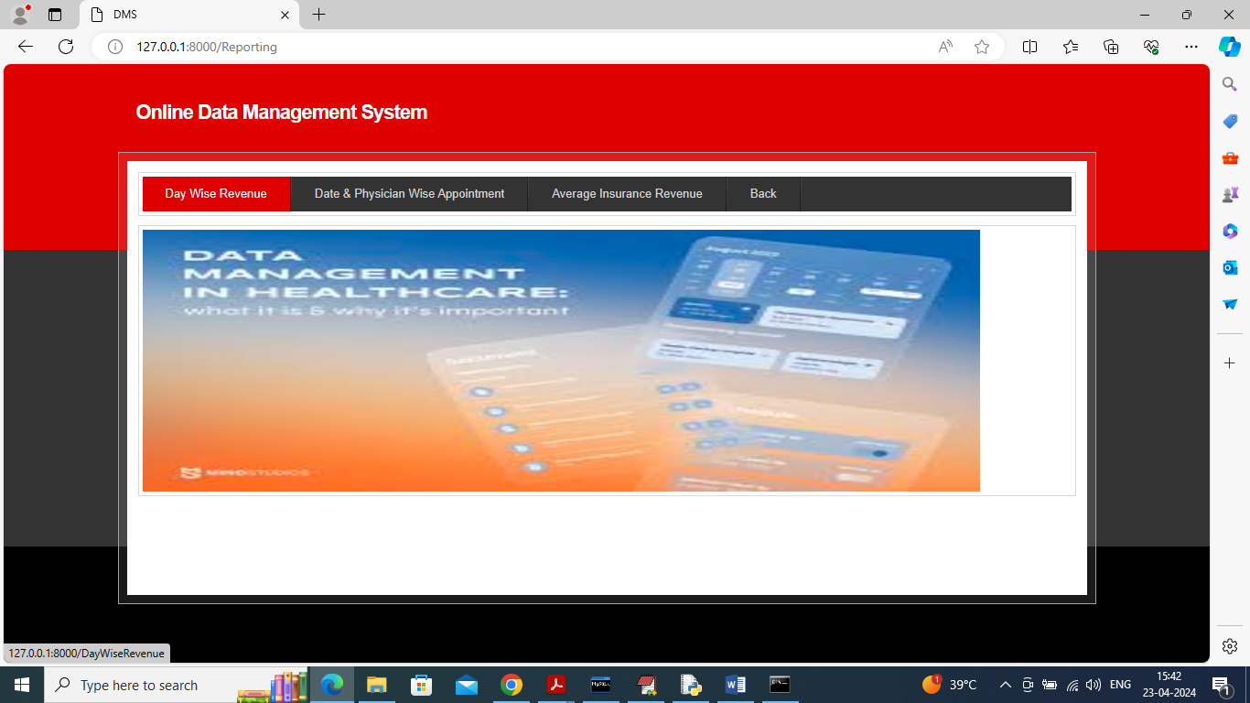

In above screen click on ‘Day wise revenue’ link to get below page

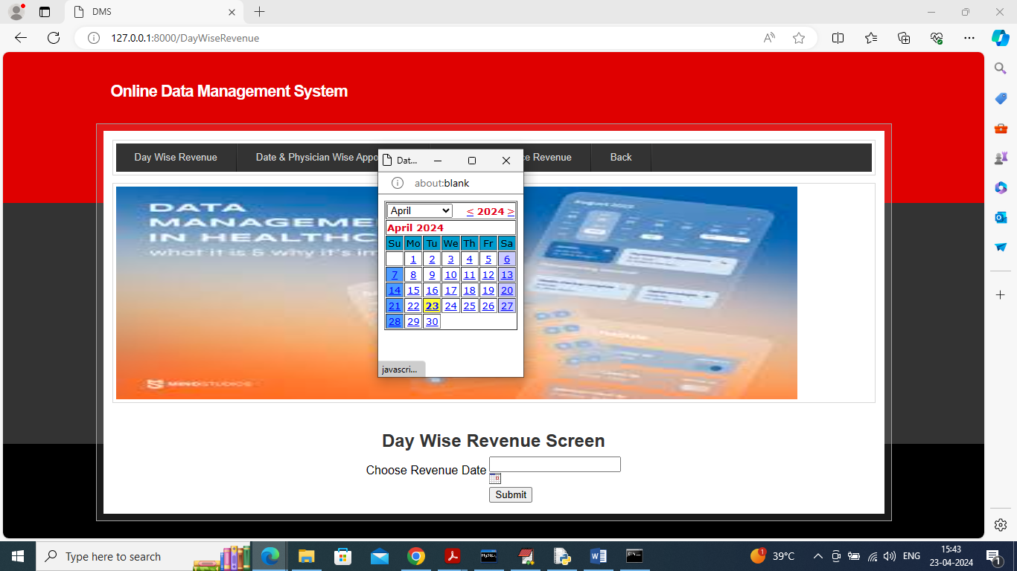

In above screen select date and then press button to view selected date sub and total payments

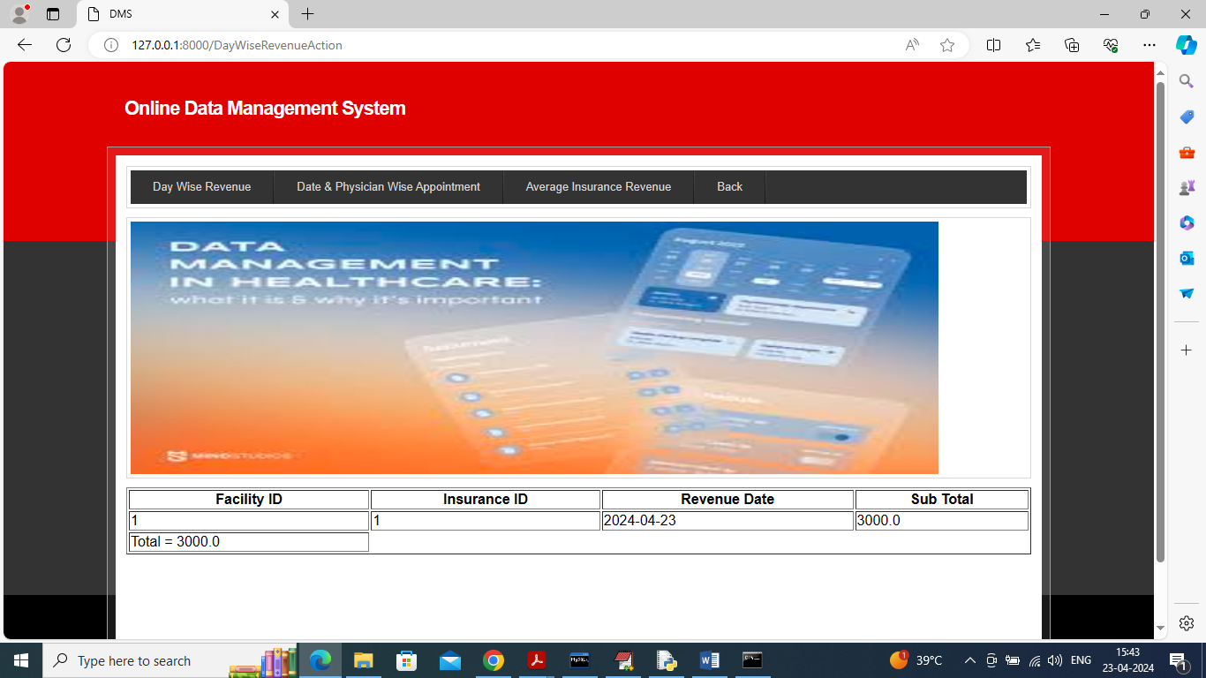

In above screen can see sub and total payment and now click on ‘Date & Physician Wise Appointment’ link to get below page

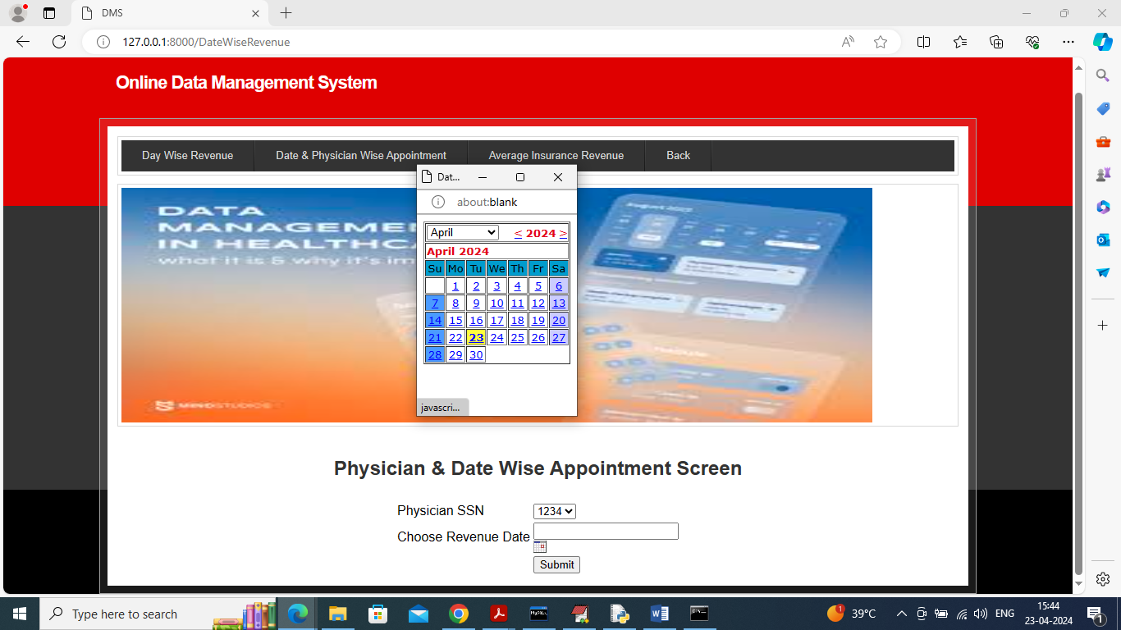

In above screen select physician SSN and then choose date to view list of appointments for selected date and doctor

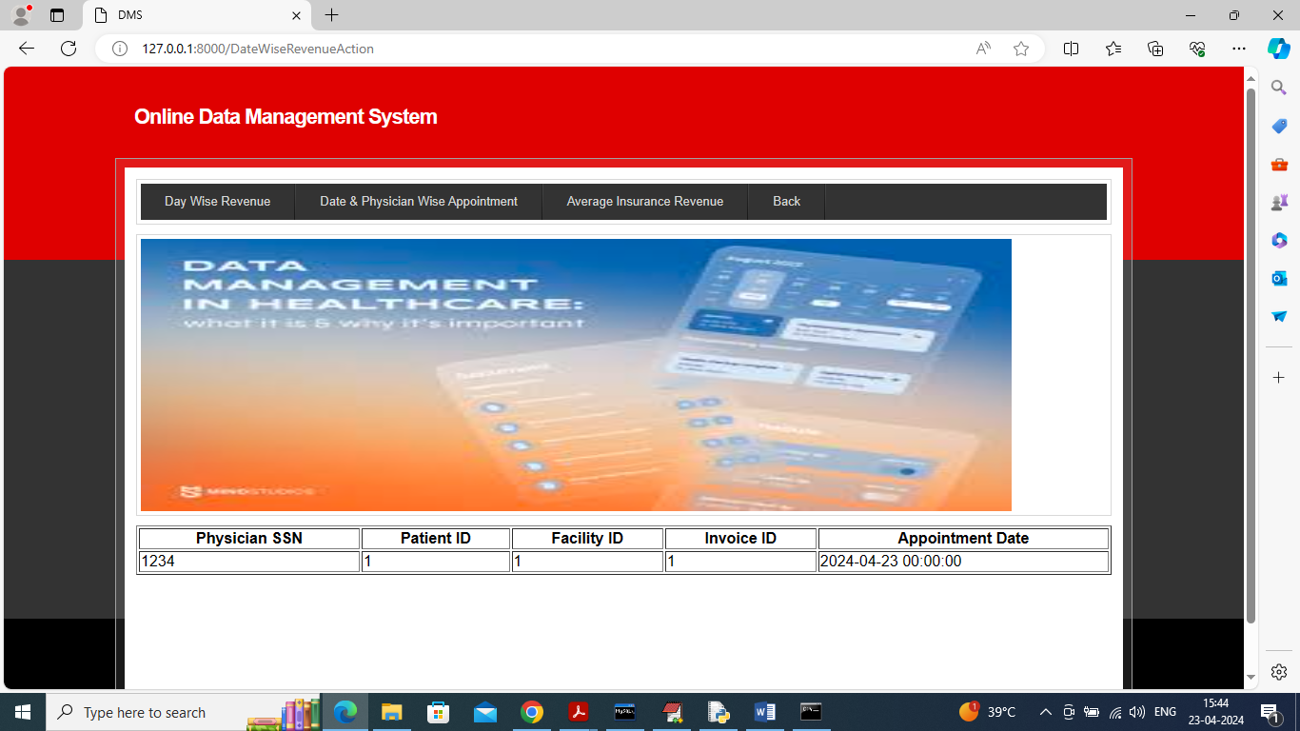

In above screen can see list of appointments and now click on ‘Average Insurance Revenue’ link to view average revenue of each insurance company for selected time period.

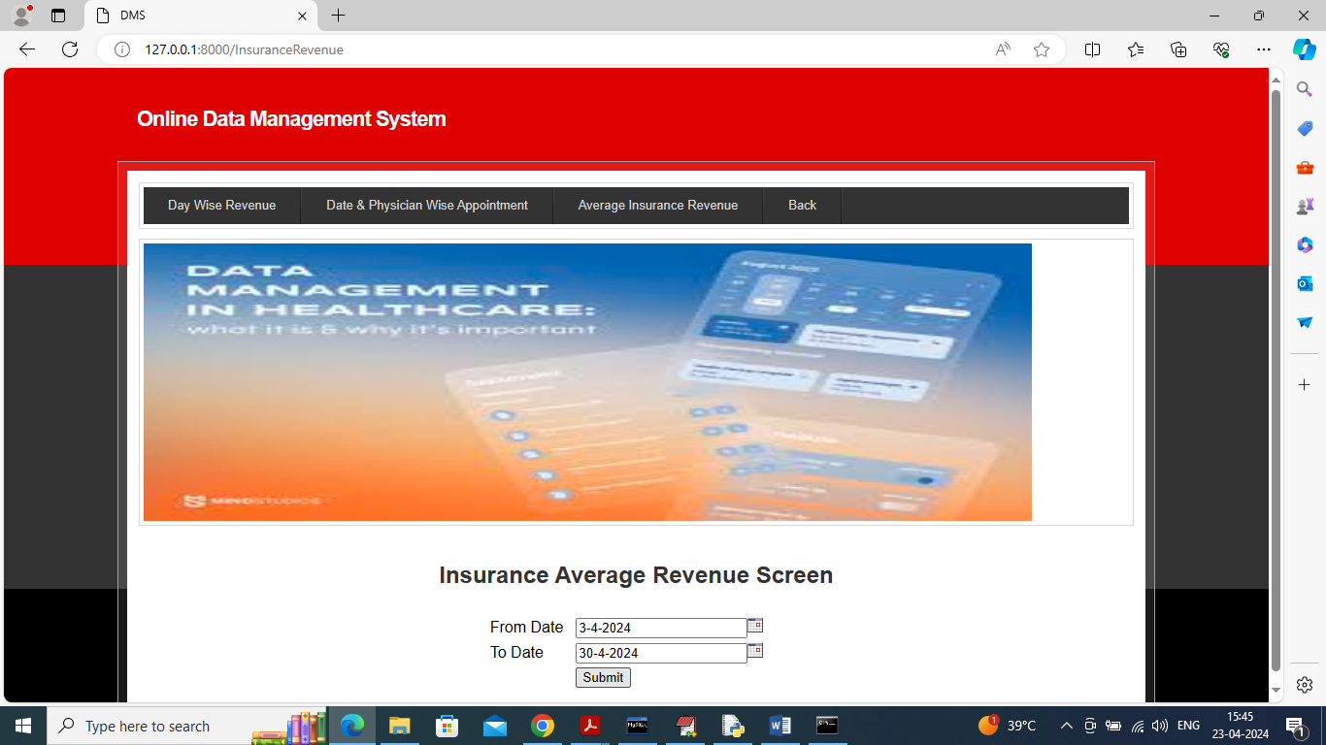

In above screen select from and to date and then press button to view average revenue and get below page

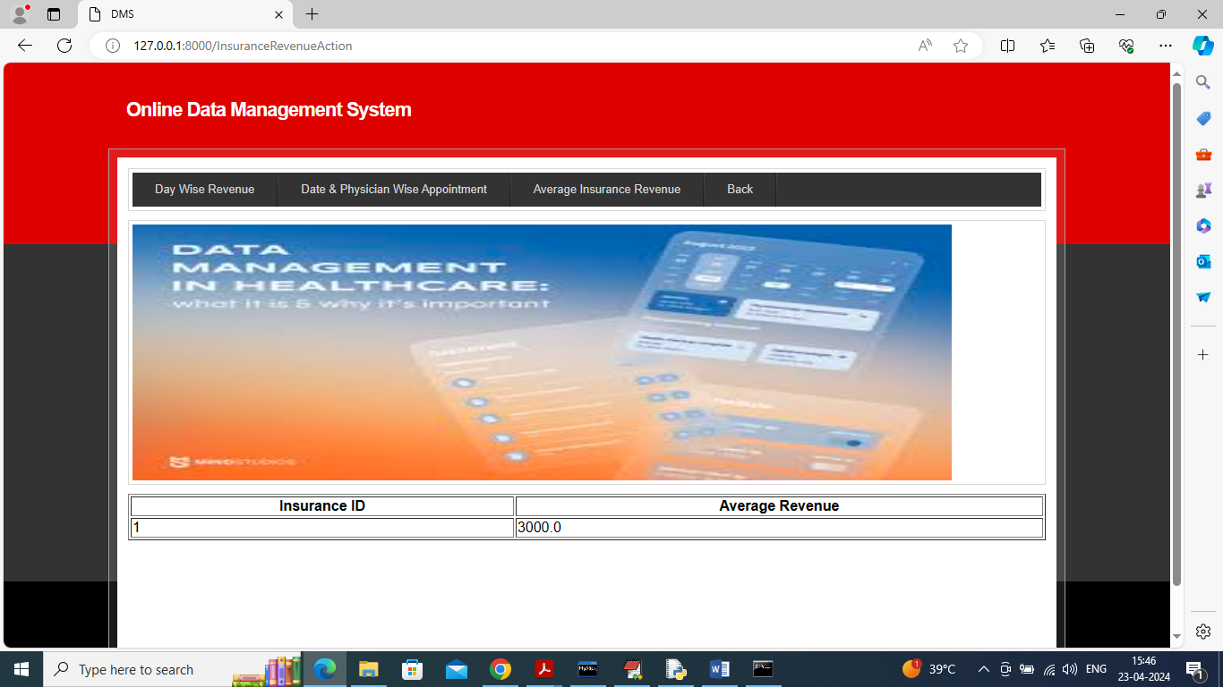

In above screen can see average revenue for each insurance company.

Similarly by following above screens you can manage all details of Morris health care.